Page - https://ensurekar.com/iso-certification

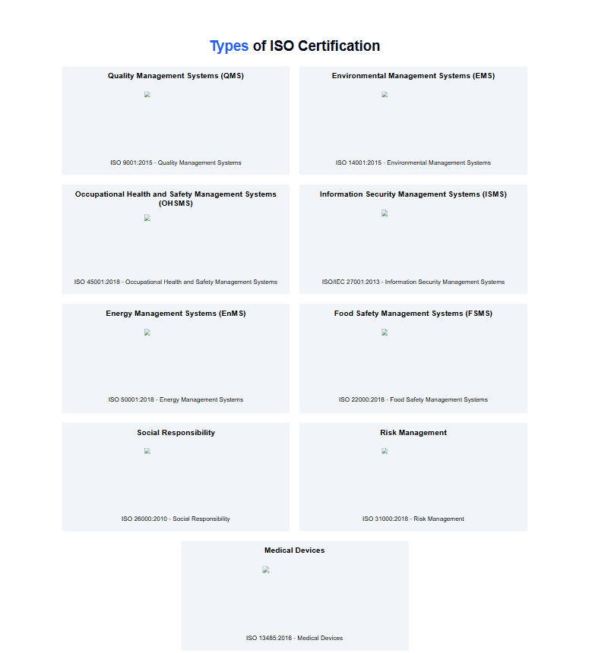

1. **Quality Management Systems (QMS)**



1. **Environmental Management Systems (EMS)**



1. **Occupational Health and Safety Management Systems (OHSMS)**



4 **Information Security Management Systems (ISMS)**



**5.Energy Management Systems (EnMS)**



**6. Food Safety Management Systems (FSMS)**

7. **Social Responsibility**



8. **Risk Management**



9. **Medical Devices**

